Describing a pair of forces

Forces always happen in pairs.
If I push the table, the table pushes my hand.
It squashes my hand.
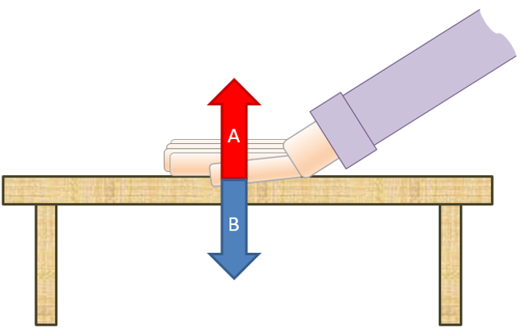

- Read each statement about forces A and B.
For each statement, tick (✓) one column to show what you think about it.

Statements |  | I am sure this is right | I think this is right | I think this is wrong | I am sure this is wrong
A | Force A is the force of the table on my hand.
B | The force the table pushes my hand is the opposite direction to the force I push the table with.
C | If I push harder, the table pushes harder on my hand.
D | The force the table pushes my hand is the same size as the force I push the table with.

Physics > Big idea PFM: Forces and motion > Topic PFM1 Forces > Key concept PFM1.2: Describing forces
Diagnostic question
Describing a pair of forces

Overview
Learning focus: | Forces arise when two objects interact; the force on one object is always equal in size, and opposite in direction to the force on the other object; force arrows indicate the size, direction and location of each force.
Observable learning outcome: | Describe how forces always arise in pairs and how the force exerted by object A on object B is equal in size and opposite in direction to the force exerted by object B on object A.
Question type: | Diagnostic, confidence grid
Key words: | Force

B | BRIDGING  This diagnostic question probes understanding of ideas that are usually taught at age 14-16, to build a bridge to later stages of learning.

What does the research say?
Driver et al (1994) stress the importance of paying attention to Newton’s third law in a teaching sequence. They suggest it helps students to appreciate that a force is not a property of an object but forces are characteristic of actions between objects.
Research by Terry et al (1985) has shown that expressing it in the form: “for every action (force) there is an equal and opposite reaction” is confusing for students aged 11-16. It is far clearer to describe in full: the force of object A on object B is equal in size, and opposite in direction to the force of object B pushing on object A.
A key problem for students’ understanding of Newton’s third law is the difficulty in recognising a force of reaction. This is why this diagnostic question concentrates on unpicking students’ understanding of it.
Ways to use this question
Students should complete the confidence grid individually. This could be a pencil and paper exercise, or you could use an electronic ‘voting system’ or mini white boards and the PowerPoint presentation.
If there is a range of answers, you may choose to respond through structured class discussion. Ask one student to explain why they gave the answer they did; ask another student to explain why they agree with them; ask another to explain why they disagree, and so on. This sort of discussion gives students the opportunity to explore their thinking and for you to really understand their learning needs.

Differentiation
You may choose to read the questions to the class, so that everyone can focus on the science. In some situations it may be more appropriate for a teaching assistant to read for one or two students.
Expected answers
All four statements are correct.
How to respond - what next?
Statement A describes the reaction force of the table. You could ask students to put their palms together and push with one hand. To keep their hands still, they need to push back with their other hand, which is the reaction force.
Statement B can also be explained using the hands analogy – it is the direction the second hand would need to push. And statements C and D likewise can be explained by what the second hand would need to do if the first hand pushed harder.
If students have misunderstandings about the reaction force or Newton’s third law, then it is helpful to ‘bridge’ their understanding between prior ideas and science ideas. The following BEST ‘response activities’ could be used to do this in follow-up to this diagnostic question:
- Response activity: Adding weight
- Response activity: Holding a weight
Acknowledgments
Developed by Peter Fairhurst (UYSEG).
Images: UGSEG
References
Driver, R., Squires, A., Rushworth, P. and Wood-Robinson, V. (1994) Making sense of secondary science, research into children’s ideas, Routledge, London, England.
Terry, C., Jones, G. and Hurford, W. (1985) ‘Children’s conceptual understanding for force and equilibrium’, Physics Education 20(4): 162-5.

